

International School

**Capstone Project 2**

CMU-SE 451

**Architecture Design**

Version 1.2

Date: 08 May 2021

**SENIOR PROJECT MANAGEMENT SYSTEM**

**FOR INTERNATIONAL SCHOOL**

**Submitted by**

Tien, Nguyen Van

Phuoc, Ha Duc

Huy, Truong Dong

Dat, Nguyen Thanh

**Approved by**

Chau, Truong Ngoc

**Proposal Review Panel Representative:**

Name Signature Date

**Capstone Project 2- Mentor:**

Name Signature Date

**PROJECT INFORMATION**

|  |  |  |  |  |  |
| --- | --- | --- | --- | --- | --- |
| **Project acronym** | Senior Project Management System for International School | | | | |
| **Project Title** | SPMS | | | | |
| **Start Date** | 18 Feb 2022 | | **End Date** | 15 May 2022 | |
| **Lead Institution** | International School, Duy Tan University | | | | |
| **Project Mentor** | Chau, Truong Ngoc | | | | |
| **Scrum master / Project Leader & contact details** | Tien, Nguyen Van  Email: cnnguyenvantien@gmail.com  Tel: 0704.042.832  Student ID: 24211208536 | | | | |
| **Partner Organization** |  | | | | |
| **Project Web URL** |  | | | | |
| **Team members** | **Name** | **Email** | | | **Tel** |
| 24211202634 | Phuoc, Ha Duc | dphuoc432000@gmail.com | | | 0961622464 |
| 24211206538 | Huy, Truong Dong | huydongtruong@gmail.com | | | 0358040650 |
| 24211206470 | Dat, Nguyen Thanh | ngthanhdat521@gmail.com | | | 0767836541 |

**REVISION HISTORY**

| **Version** | **Date** | **Comments** | **Author** | **Approval** |
| --- | --- | --- | --- | --- |
| v1.0 | 26/02/2022 | Initial Release | Dat | x |
| v1.1 | 05/05/2022 | Update document | Dat | x |
| v1.2 | 08/05/2022 | Format document | Phuoc | x |
|  |  |  |  |  |

Table of Contents

**1. Introduction 7**

1.1. Project Overview 7

1.2. Purpose 7

**2. Architecture driver 7**

2.1. Business constraints 8

2.2. Technical constraints 8

2.3. Function requirements 8

2.4. Quality attributes 8

2.2.1. Utility table 8

2.2.2. Quality attributes 9

2.2.2.1. Security 9

2.2.2.2. Usability 9

2.2.2.3. Correctness 10

2.2.2.4. Performance 10

2.2.2.5. Modifiability 11

2.2.2.6. Availability 11

**3. Architecture overview 12**

3.1. System context 12

3.2. Component and connector 14

3.3. Module view 18

3.2. Allocation view 19

**4. References 21**

Table of Figure

**Figure 3.1:** *Context Diagram.* 12

**Figure 3.2.1:** *Component and connector for moderator.* 14

**Figure 3.2.1:** *Component and connector for mentor.* 15

**Figure 3.2.1:** *Component and connector for student.* 15

**Figure 3.2.1:** *Component and connector for admin.* 16

**Figure 3.3.1:** *Module view for client.* 18

**Figure 3.3.2:** *Module view for server.* 18

**Figure 3.4:** *Allocation view.* 19

Table of Tables

**Table 2.4.2.1:** *Security.* 9

**Table 2.4.2.2:** *Usability.* 9

**Table 2.4.2.3:** *Correctness.* 10

**Table 2.4.2.4:** *Performance.* 10

**Table 2.4.2.5:** *Modifiability.* 11

**Table 2.4.2.6:** *Availability..* 11

**Table 3.2:** *Component and connector prose.* 16

**Table 3.3:** *Module view prose.* 19

**Table 3.4:** *Allocation prose.* 20

**SIGNATURE**

**Document Approvals:** *The following signatures are required for approval of this document.*

|  |  |  |
| --- | --- | --- |
| Chau, Truong Ngoc  *Mentor* |  | Date: |
| Tien, Nguyen Van  *Scrum Master* |  | Date: |
| Phuoc, Ha Duc  *Product Owner* |  | Date: |
| Huy, Truong Dong  *Member* |  | Date: |
| Dat, Nguyen Thanh  *Member* |  | Date: |

1. **Introduction**
   1. **Project overview**

The SPMS system is a system that could help the lecturer manage students' capstones, manage student workflow, grades and communicate plans to students in a timely manner. Fast and accurate way to save time and effort. Students can track and understand their capstone process.

* 1. **Purpose**

This specification covers following:

* Brief specification of the project, high level requirement.
* Detail quality attribution.
* System context, sequence diagrams.
* Architecture presented by various view types: Component and Connect, Module view and Allocation view.

1. **Architecture driver**

**Business Problems:**

* Students need assistance with details of a capstone.
* Users need an automated system to support submission, comment, assessment, project information or score information.

**Business Need:**

* A students can communication with group or mentor.
* Support for their students can assign, see project & document template when they need it.
* Students can view group details, score, evaluate and notification.
* Administrators can manage account user, project template and document.
* Teacher can manage students, mentor, group, new & announcements, defenses, schedule, project.
  1. **Business constraints**
* Sources: 4 people.
* Project was started on: 15/02/2022.
* Project will be ended on: 15/05/2022.
* Project will be finished in 90 days (1440 hours).
* Cost: $3680.
  1. **Technical constraints**
* **Database:** Postgres SQL.
* **Back-end:**
* Programming Language: Javascripts.
* Framework: Express (NodeJS), Nodemon.
* Libraries: Node-Postgres.
* **Front-end:**
* Programming language: HTML, CSS, Javascript.
* Framework: React, Hook.
* **Client:**
* Operating System: Windows.
* Web Browser: Chrome.
  1. **Function requirements**

References to Product Backlog specification of ProductBacklogV1.0.docx.

* 1. **Quality attributes**
     1. **Utility table**

There are following quality attributes that drive the design of architecture. Each quality attribute scenario is ranked with importance (I) defined by the Product Owner, and the estimated level difficulty (D). Both values are based on a scale of High (H) - Medium (M) - Low (L).

* + 1. **Quality attributes**
       1. **Security**

Table 2.4.2.1: *Security.*

|  |  |
| --- | --- |
| **Scenario:** When user login into the system, the system will ensure security with user’s account. | |
| Type | Security |
| Stimulus | Ensure security in the account. |
| Source of stimulus | User |
| Environment | Normal |
| Artifact stimulated | System |
| Response | Encode password |
| Response measure | Account protection |

* + - 1. **Usability**

Table 2.4.2.2: *Usability.*

|  |  |
| --- | --- |
| **Scenario:** When user has logged in successfully, the system will save user’s session. | |
| Type | Usability |
| Stimulus | Save user’s session |
| Source of stimulus | User |
| Environment | Normal |
| Artifact stimulated | System |
| Response | User access into the system |
| Response measure | User don’t need to login more |

* + - 1. **Correctness**

Table 2.4.2.3: *Correctness.*

|  |  |
| --- | --- |
| **Scenario:** When the user performs operations, the corresponding information will be updated correctly. | |
| Type | Correctness |
| Stimulus | Performs operations |
| Source of stimulus | User |
| Environment | Normal |
| Artifact stimulated | System |
| Response | Change the information |
| Response measure | The corresponding information will be updated correctly. |

* + - 1. **Performance**

Table 2.4.2.4: *Performance.*

|  |  |
| --- | --- |
| **Scenario:** When user access the system, the requests from user will be processed maximum 3 seconds. | |
| Type | Performance |
| Stimulus | The requests from user will be process quickly |
| Source of stimulus | User |
| Environment | Normal |
| Artifact stimulated | System |
| Response | Data will display |
| Response measure | Maximum 3 seconds |

* + - 1. **Modifiability**

Table 2.4.2.5: *Modifiability.*

|  |  |
| --- | --- |
| **Scenario:** When user access into the system, user want to operate easily with features. | |
| Type | Modifiability |
| Stimulus | Update the User Interface after modifying data. |
| Source of stimulus | User |
| Environment | Normal |
| Artifact stimulated | System |
| Response | Make modification without affecting other functionality, Test modification, Deploy modification |
| Response measure | Repair time not exceed 3 hours (Time interval when the system is in degraded mode) |

* + - 1. **Availability**

Table 2.4.2.6: *Availability.*

|  |  |
| --- | --- |
| **Scenario:** When user access into the system, the website can usually access. | |
| Type | Availability |
| Stimulus | User access usually the website |
| Source of stimulus | User |
| Environment | Normal |
| Artifact stimulated | System |
| Response | Usually access |
| Response measure | 20 hours / day |

1. **Architecture overview**

This section shows the diagrams which bounds our target system and describes the architecture and interaction between components

* 1. **System context**

**Figure 3.1:** *Context Diagram.*

* Manage account:
* Admin can add, update, delete account of user.
* Manage template topic:
* Admin can upload, delete template document.
* Student can view and download template document.
* Register and execute capstone:
* Student can fill in form information and submit it to register execute capstone
* Student will wait to moderator approve and system will send account to mail of student.
* Register topic:
* Student can fill in form register topic and submit it to register topic for project.
* Student can choose topic template of mentor in topic template list.
* Moderator will approve and student can use it for capstone project.
* Manage task for project:
* Student can create stage for project.
* In each stage student can create task and assign it for members.
* In each task member can comment issue and report task done or late.
* Mentor can see stage and comment in each task of project.
* Manage student:
* Moderator can add, update, delete student.
* Moderator can approve for student can execute project and system will send account for student.
* Manage group:
* Moderator can create group and divide student and mentor for each group.
* Moderator can update, delete and export file excel group list.
* Manage defense:
* Moderator can divide defense and assign positions to each person.
* Moderator can update, delete and export file excel defense list.
* Manage topic:
* Moderator can view topic template list and topic of student list.
* Moderator can approve for topic of student.
* Manage notification:
* Moderator can create, update, delete notification.
* Submit topic template:
* Mentor can upload file topic template or fill in form topic template for student.
* Manage score:
* Mentor and Evaluator can input score of each member of group.
* Evaluator can export file summary score.
* Evaluate work quality:
* The system will aggregate the percentage of each member's contribution and sum it up.
* Mentor can see and evaluate work quality of each member.
  1. **Component and connector**
* We mainly used a C&C view to argue and reason about architectural properties, quality attribute requirements, and functional requirements that the system must add here.
* This view type partitions the system into components that have some runtime presence such as processes, objects, data stores, and connectors or that represent pathways of communication such as data flows and access to shared storage.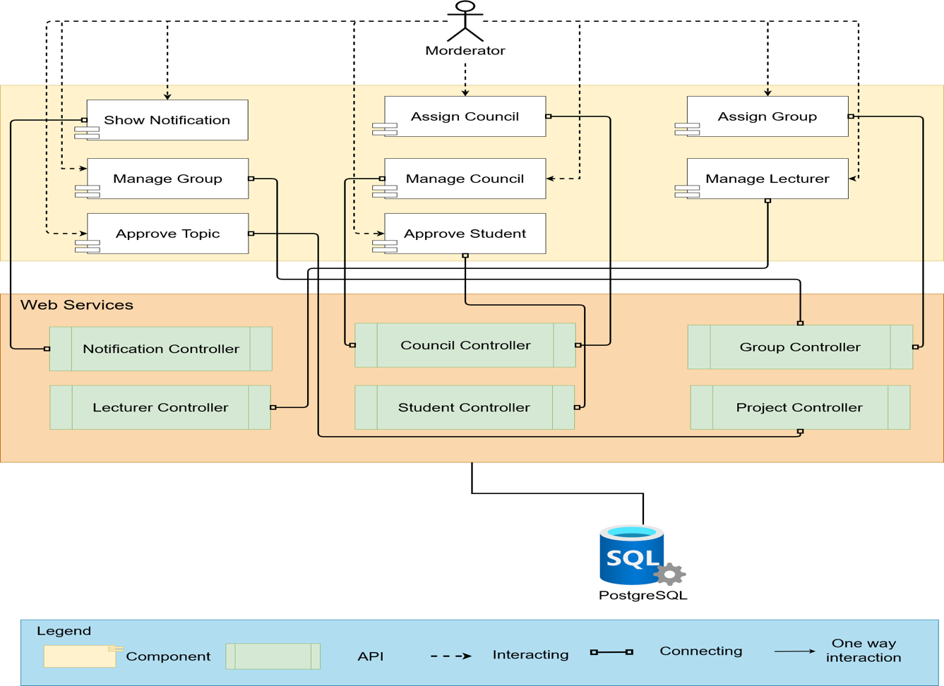

Figure 3.2.1: *Component & connector for moderator.*

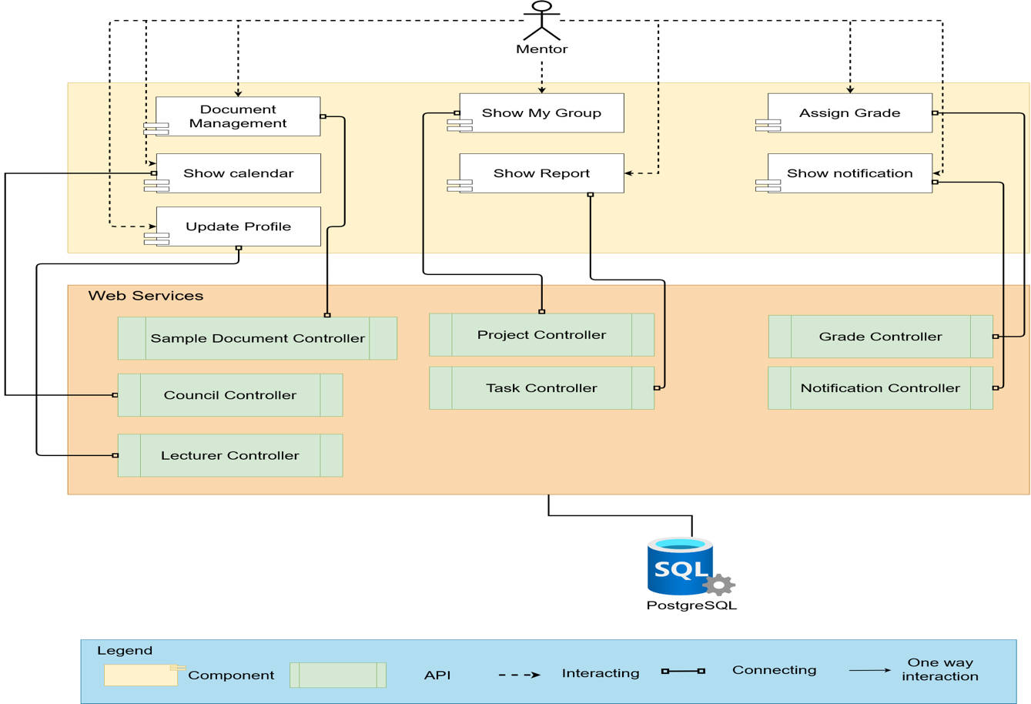

Figure 3.2.2: *Component & connector for mentor.*

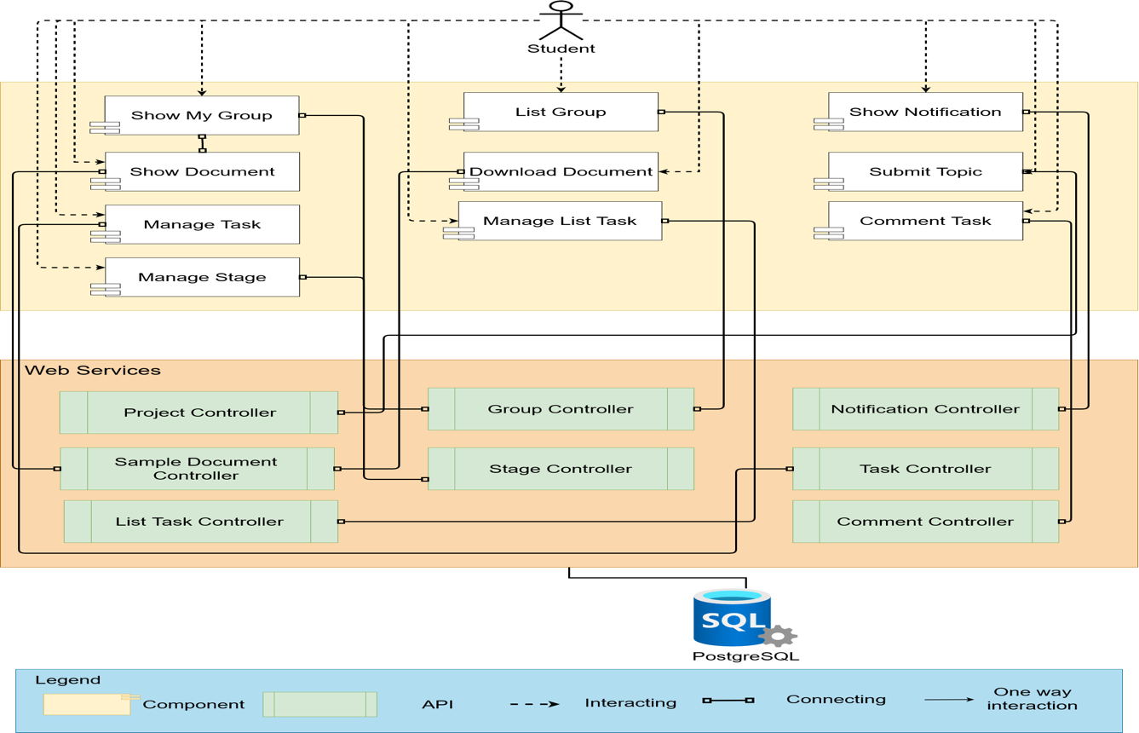

Figure 3.2.3: *Component & connector for student.*

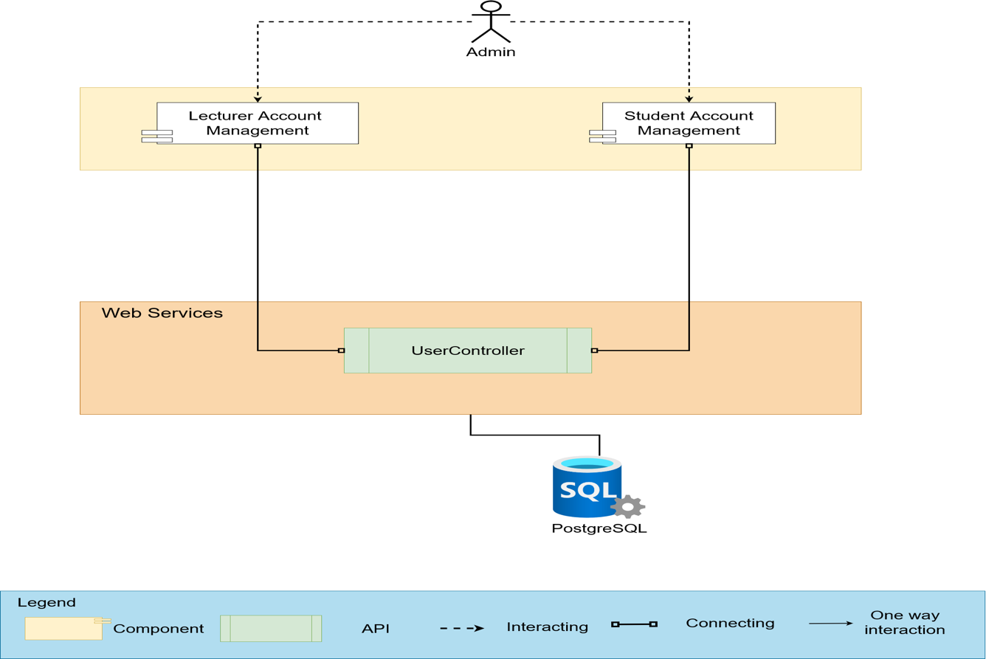

Figure 3.2.4: *Component & connector for admin.*

**Prose**

Table 3.2: *Component & connector prose.*

|  |  |
| --- | --- |
| **Element** | **Responsibilities** |
| Show notification | User can see the notifications in the website. |
| Assign Council | Moderator can assign council into a group. |
| Assign Group | Moderator can assign group into a lecturer. |
| Manage Group | Moderator can add, update, remove group and show a list of groups. |
| Manage Council | Moderator can add, update, remove council and show a list of councils. |
| Manage Lecturer | Moderator can add, update, remove lecturer and show a list of lecturer. |
| Approve Topic | Moderator can approve topic from the student. |
| Approve Student | Moderator can approve student account from the student. |
| Document Management | Mentor can add, edit and remove files and folders. |
| Show My Group | Mentor and Student can see their group. |
| Assign Grade | Evaluator can assign grade for the students in a group. |
| Show Calendar | Mentor and Student can see the schedule of their councils. |
| Show Report | Mentor can see statical reports by every stages. |
| Update Profile | Lecturer can update their information. |
| List Group | Student can see all groups. |
| Show Document | Student can see sample documents. |
| Download Document | Student can download the sample documents. |
| Manage Task | Student can add, edit and remove tasks and assign tasks for members. |
| Manage List Task | Student can add, edit and remove a list of tasks. |
| Comment Task | Student can comment the tasks. |
| Manage Stage | Student can add, edit and remove a stage. |
| Lecturer Account Management | Admin can edit the lecturer accounts and reset password. |
| Student Account Management | Admin can edit the student accounts and reset password. |

* 1. **Module view**

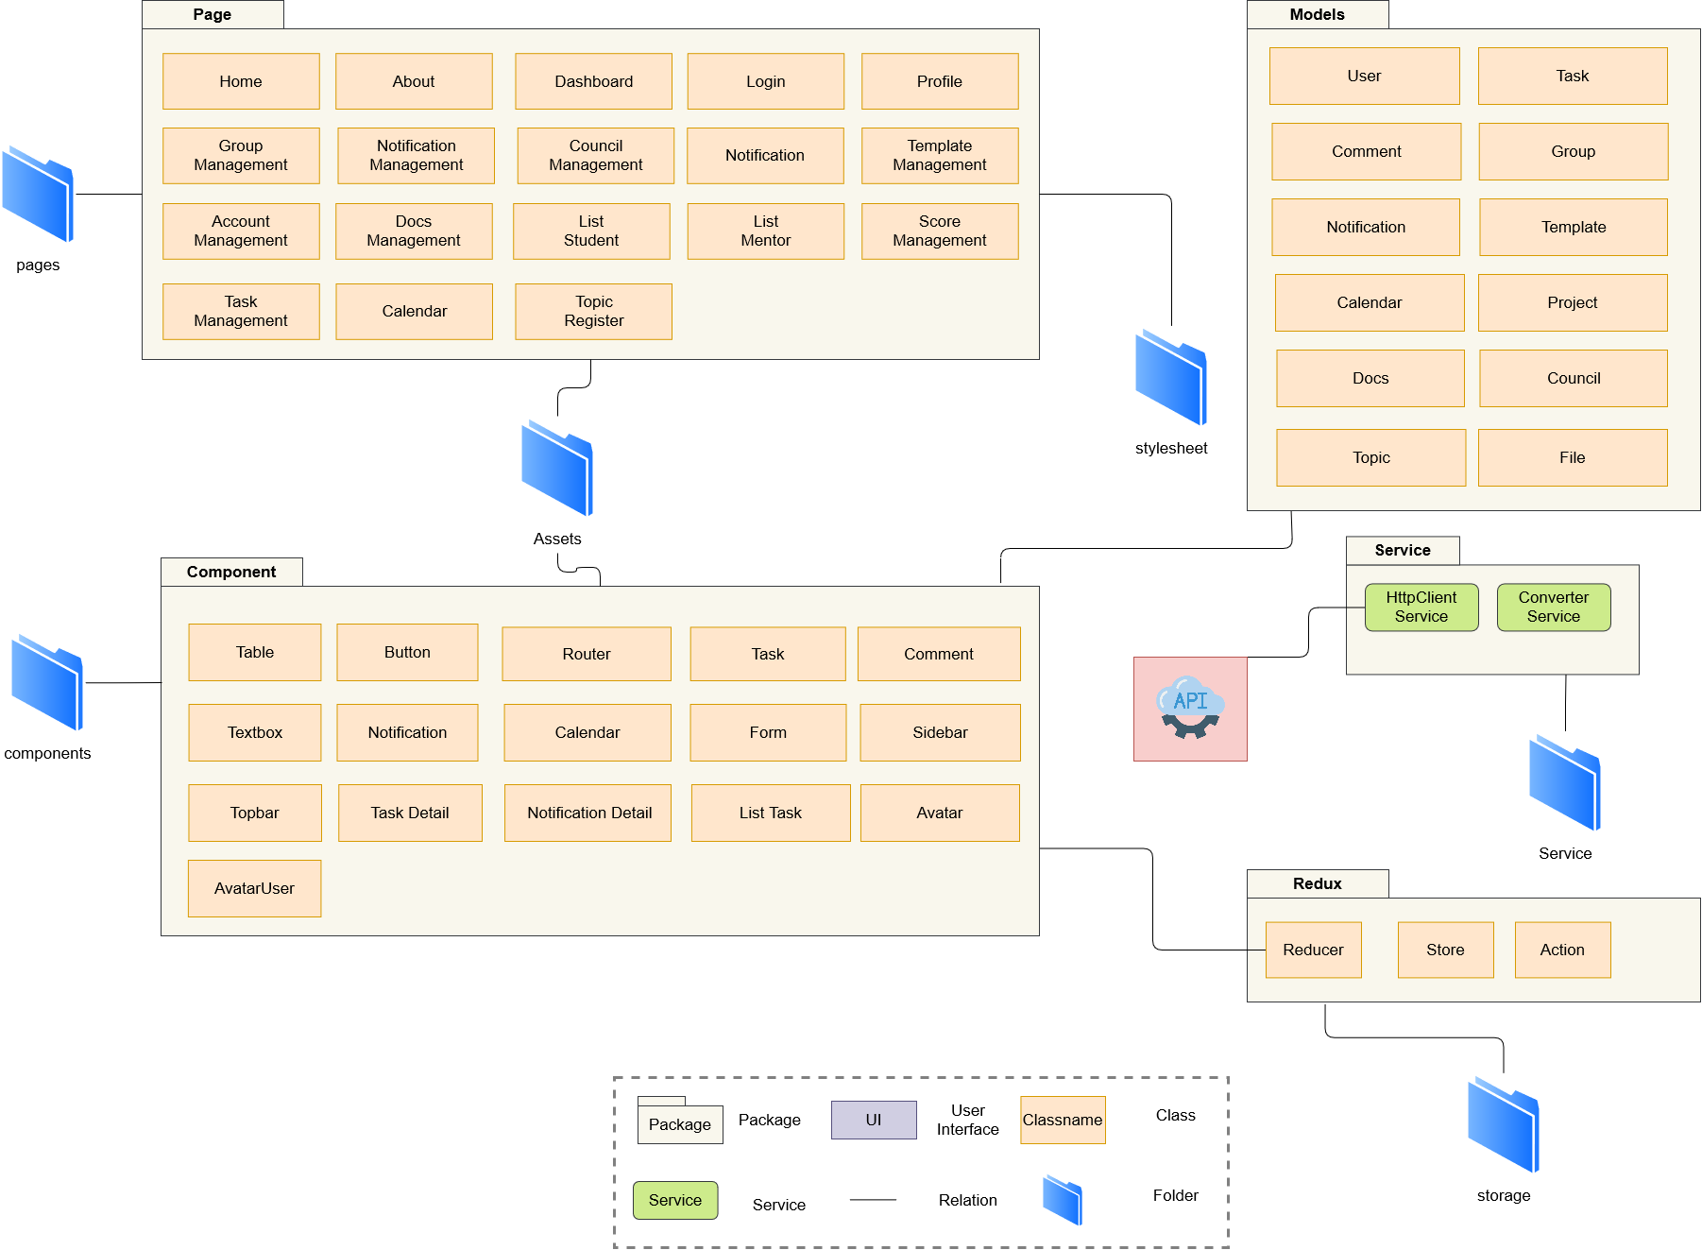

Figure 3.3.1: *Module view for client.*

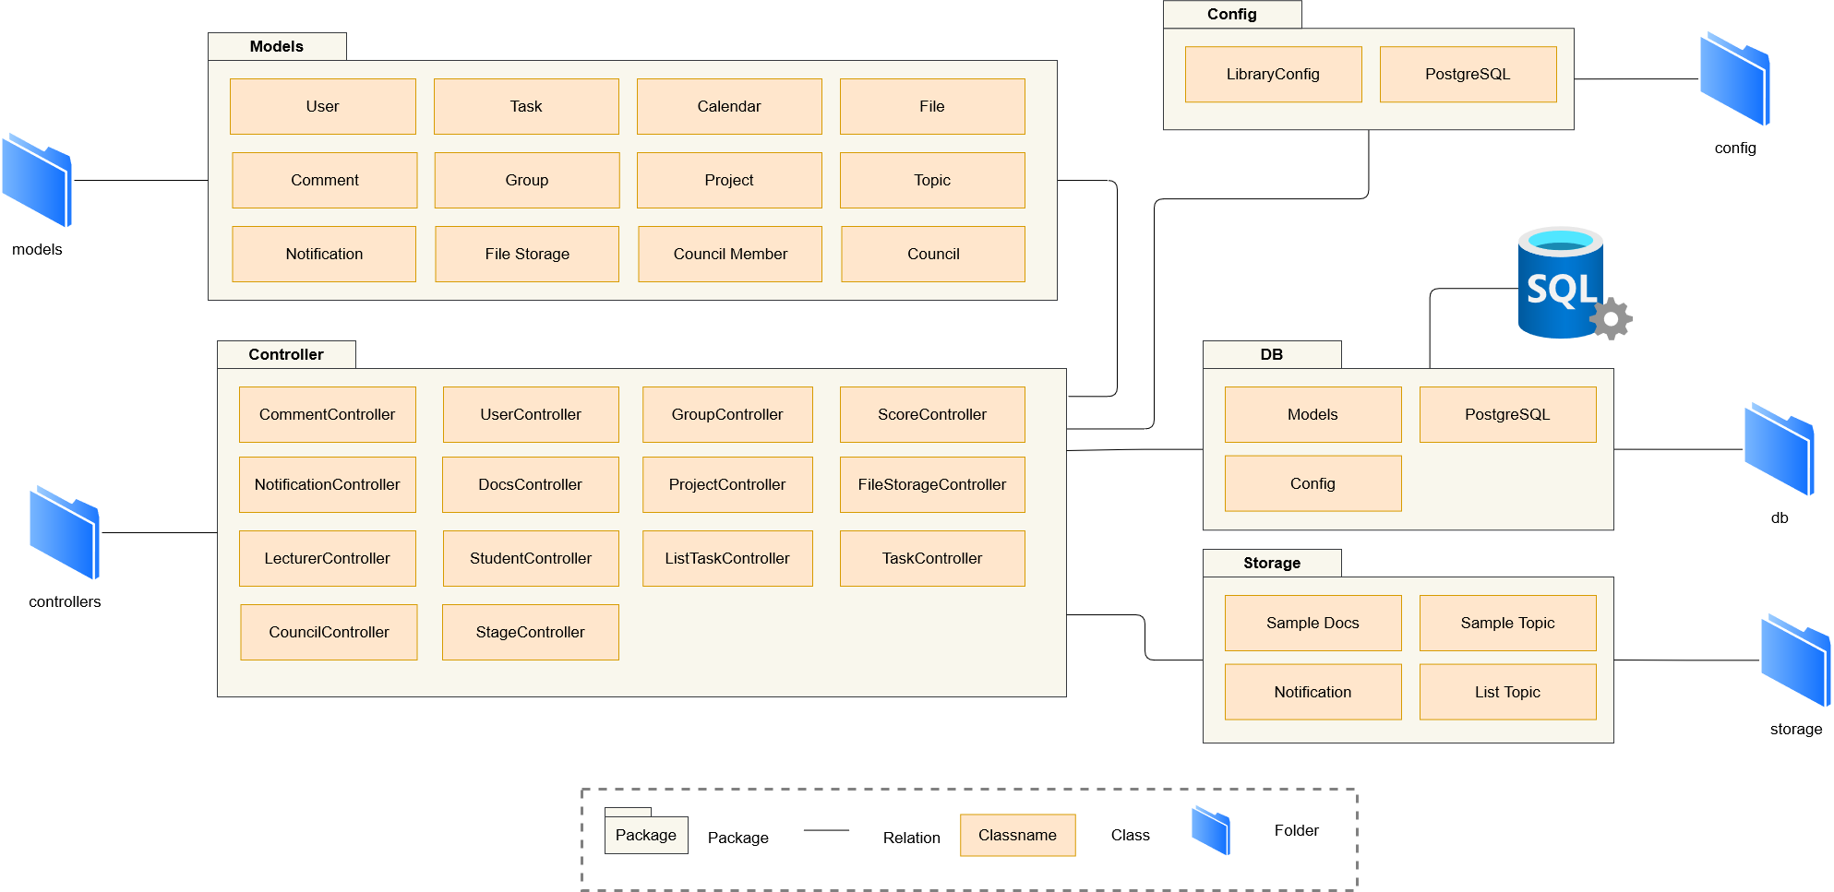

Figure 3.3.2: *Module view for server.*

**Prose**

Table 3.3: *Module view prose.*

|  |  |
| --- | --- |
| **Element** | **Responsibilities** |
| Web View | The website package contains management modules for admin, students, mentor, moderator. |
| Models | Object data modules connect to tables in the database for transmission to the system interface. |

**Description**

The system includes web view, services, and models. After users interact with UI. Data will be requested to the corresponding service, then will direct to model. Data be responded will be displayed on UI.

* 1. **Allocation view**

The allocation view models the run-time architecture of a system. It shows the configuration of the hardware elements when the system is deployed.

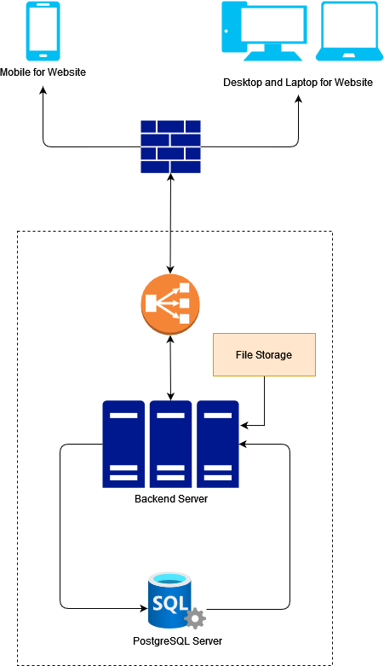

Figure 3.4: *Allocation view.*

**Prose**

Table 3.4: *Allocation view prose.*

|  |  |
| --- | --- |
| **Element** | **Responsibilities** |
| Laptop or PC | Device running browser and helping Admin, Students, Mentor, Moderator to use the functions of the website to manage. |
| Backend Server | Provide an API to support the interaction between the user interface and the server. where to install and run the backend API. |
| PostgreSQL Database | The place contains all data about tours, user information... It is organized in tabular form. |

**Description**

The system is deployed on web environment (using React JS library). They interact with the server through APIs to read and write data from the PostgreSQL database. In addition.

1. **References**

[1] Design standards, Document standards.

<https://www.softwarearchitecturebook.com/svn/main/slides/ppt/26_Standards.ppt>.

<https://standards.ieee.org/standard/1471-2000.html>.

<https://ieeexplore.ieee.org/document/917550>.

[2] Patterns.

<https://en.wikipedia.org/wiki/Architectural_pattern>.

[3] Evaluation standards.

<https://www.iso.org/obp/ui/#iso:std:iso-iec-ieee:42030:ed-1:v1:en>.

<https://gabrielfs7.github.io/software-architecture/2019/10/18/atam-analyze-evaluate-architecture/>.